Santhosh P – 22CSR177 III CSE C

DAY -1 NGINX, DOCKER IMAGES PUSH AND RUN THE CONTAINER

Docker

**Docker** is an open-source platform that allows developers to build, package, and run applications in isolated environments called **containers**. It enables applications to run consistently across different systems by bundling all dependencies, libraries, and configurations into a standardized unit.

Docker simplifies software deployment, improves scalability, and ensures applications work the same way across development, testing, and production environments

A **Docker image** is a lightweight, standalone, and executable software package that includes everything needed to run an application: the code, runtime, libraries, environment variables, and dependencies. It serves as a blueprint for creating **Docker containers**.

A **Docker container** is a running instance of a Docker image. It is an isolated environment that runs applications consistently across different systems. Containers are lightweight, fast, and portable, making them ideal for deployment in various environments without compatibility issues.

OUTPUT:

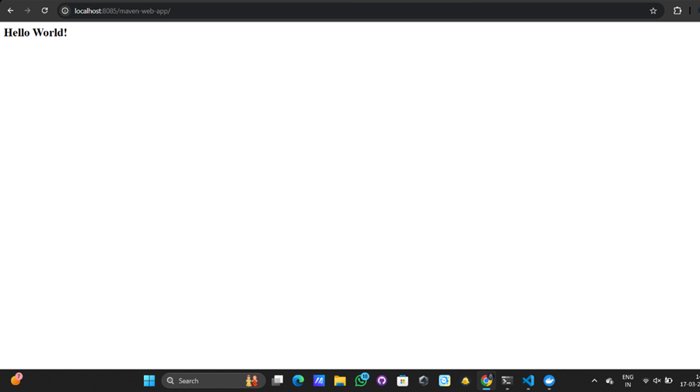

# Pull the Nginx Docker image

docker pull nginx

# Create a directory for the HTML file

mkdir -p ~/nginx-html

# Create a simple "Hello World" HTML file

echo "<h1>Hello, World!</h1>" > ~/nginx-html/index.html

# Run the Nginx container and mount the HTML file

docker run -d -p 8080:80 -v ~/nginx-html:/usr/share/nginx/html --name my-nginx nginx

Docker initial commands:

Docker login

Docker login -u <username> -p <password>

Docker build -t my-web-app .

Docker push my-web-app